

**Lab # 05**

**Student Name: Waseem Akram**

**Roll Number: BIT-23F-001**

**Section: A**

**Subject: Artificial Intelligence**

**Department: BS Information Technology**

**Lab # 05**

**Objective:**

The objective of this lab manual is to familiarize students with the usage of loops in Python,

which allows repeated execution of code blocks based on certain conditions.

**Introduction to Loops in Python:**

Loops in Python are a way to execute a block of code multiple times. The two main types of

loops in Python are: For Loop: Iterates over a sequence (such as a list, tuple, string, or range). While Loop: Repeats as long as a certain condition is true.

**1. Boolean Operators:**

a. And: Returns True if both operands are True.

b. OR: Returns True if either operand is True.

c. Nott: Returns the opposite boolean value of the operand.

**1. For Loop:**

The for loop is used for iterating over a sequence. It will execute the code block for each item in

the sequence.

Syntax:

for item in sequence:

# code block to execute

numbers = [1, 2, 3, 4, 5]

for number in numbers:

print(number) # Output: 1 2 3 4 5Conditional Statements:

**2. While Loop:**

The while loop allows repeated execution of a block of code as long as a specified condition is

True. Syntax:

while condition:

# code block to execute

code

count = 0

while count < 5:

print(count) # Output: 0 1 2 3 4

count += 1

Nested Loops:Loops can also be nested, meaning you can place one loop inside

another.

Code:

for i in range(3):

for j in range(3):

print(f"i = {i}, j = {j}")

Loop Control Statements: Break: Exits the loop before it has gone through all the iterations. Continue: Skips the current iteration and moves to the next one.

Code:

# Break example

for i in range(5):

if i == 3:

break

print(i) # Output: 0 1 2

# Continue example

for i in range(5):

if i == 3:

continue

print(i) # Output: 0 1 2 4

**Assignments:**

1. Print Numbers with Loops: Write a program that uses a loop to print numbers from 1 to 10.
2. Calculate the Sum of Numbers: Write a function that calculates the sum of all numbers up to a given number using a loop.
3. Display a Star Pattern: Write code using loops and nested loops to create star pattern(discussed previously).

**4.** Find Even Numbers in a List: Write a function that takes a list of numbers and prints only the even numbers.

1. Print Numbers with Loops: Write a program that uses a loop to print numbers from 1 to 10.

**Code:**

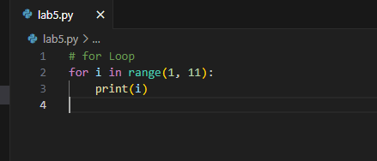

**Output:**

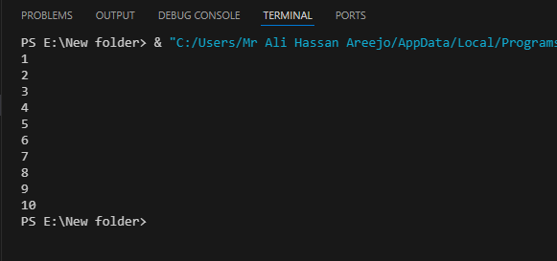

1. Calculate the Sum of Numbers: Write a function that calculates the sum of all numbers up to a given number using a loop.

**Code:**

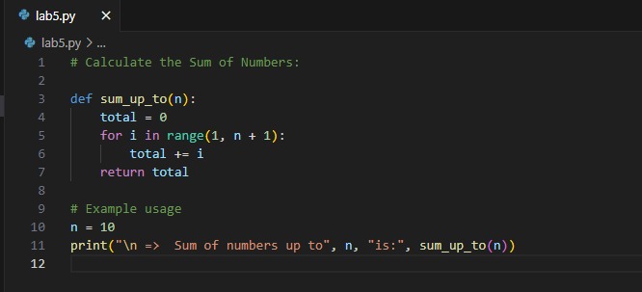

**Output:**

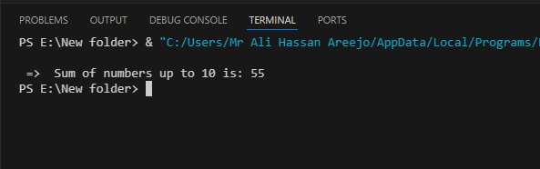

**3:** Display a Star Pattern: Write code using loops and nested loops to create star pattern(discussed previously).

**Code:**

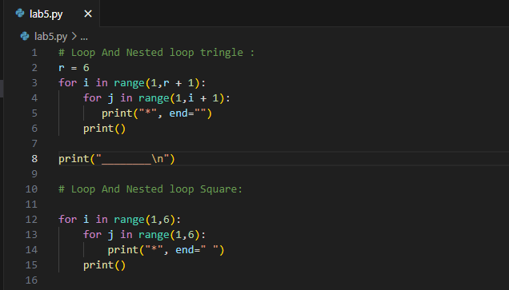

**Output:**

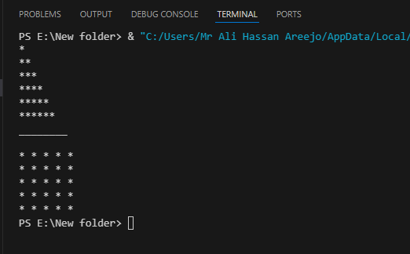

**4.** Find Even Numbers in a List: Write a function that takes a list of numbers and prints only the even numbers.

**Code:**

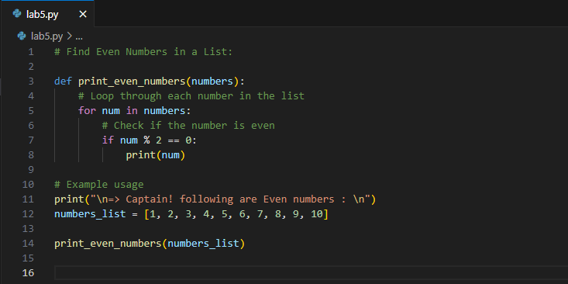

**Output:**

